NAME ________________________________________

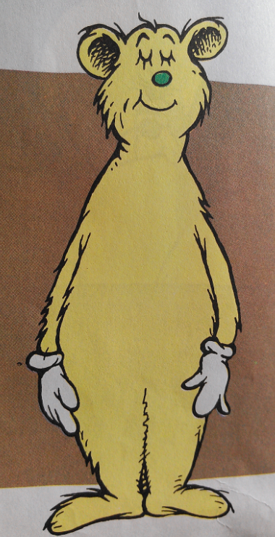

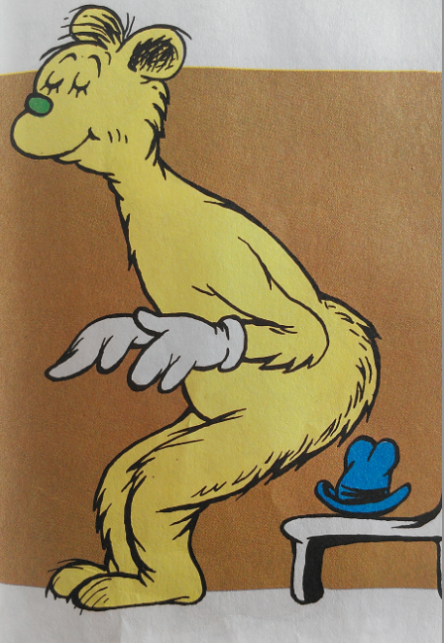

|  |  |  |
| --- | --- | --- |
| P | A |  |

|  |  |  |
| --- | --- | --- |
|  | A |  |

|  |  |  |
| --- | --- | --- |
|  | A |  |



|  |  |  |
| --- | --- | --- |
|  | A |  |

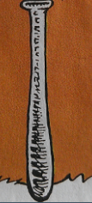

|  |  |  |
| --- | --- | --- |
|  | A |  |

